**Chapter 3**

**Vector-Valued Functions**

**3.4 Motion in Space**

**Section Exercises**

155. Given  find the velocity of a particle moving along this curve.

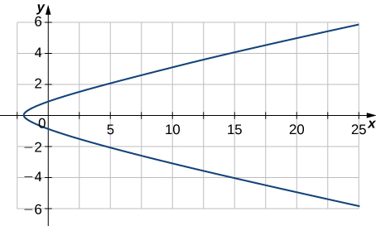

Answer: 

**Given the following position functions, find the velocity, acceleration, and speed in terms of the parameter *t*.**

157. 

Answer:   

159.  The graph is shown here:

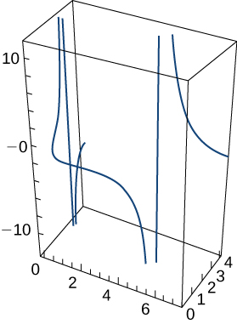

Answer:   

**Find the velocity, acceleration, and speed of a particle with the given position function.**

161. 

Answer:   

163. The position function of an object is given by  At what time is the speed a minimum?

Answer: 

**Consider the motion of a point on the circumference of a rolling circle. As the circle rolls, it generates the cycloid where  is the angular velocity of the circle and b is the radius of the circle**:

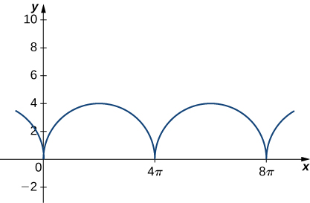

165. Find the equations for the velocity, acceleration, and speed of the particle at any time.

Answer:   

**A person on a hang glider is spiraling upward as a result of the rapidly rising air on a path having position vector  The path is similar to that of a helix, although it is not a helix. The graph is shown here:**

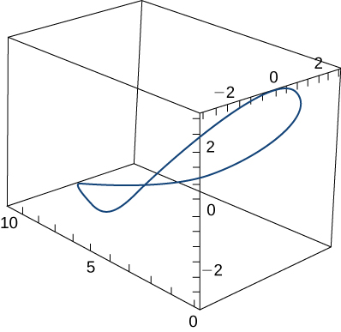

**Find the following quantities:**

167. The glider’s speed at any time

Answer: 

**Given that  is the position vector of a moving particle, find the following quantities:**

169. The velocity of the particle

Answer: 

171. The acceleration of the particle

Answer:  

**A projectile is shot in the air from ground level with an initial velocity of 500 m/sec at an angle of 60° with the horizontal. The graph is shown here:**

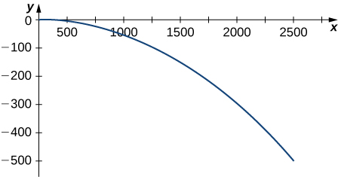

173. At what time does the projectile reach maximum height?

Answer: 44.185 sec

175. At what time is the maximum range of the projectile attained?

Answer:  sec

177. What is the total flight time of the projectile?

Answer: 88.37 sec

**A projectile is fired at a height of 1.5 m above the ground with an initial velocity of 100 m/sec and at an angle of 30° above the horizontal. Use this information to answer the following questions:**

179. Determine the range of the projectile.

Answer: The range is approximately 886.29 m.

181. A projectile is fired from ground level at an angle of 8° with the horizontal. The projectile is to have a range of 50 m. Find the minimum velocity necessary to achieve this range.

Answer:  m/sec

183. The acceleration of an object is given by  The velocity at  sec is  and the position of the object at  sec is  Find the object’s position at any time.

Answer: 

185. Find the tangential and normal components of acceleration for  at 

Answer:  

**For each of the following problems, find the tangential and normal components of acceleration.**

187.  The graph is shown here:

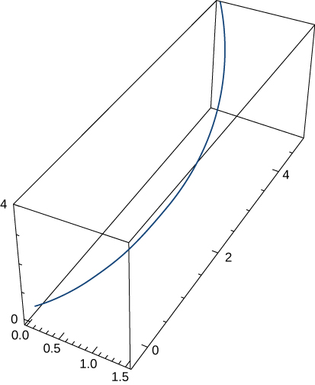

Answer:  

189. 

Answer:  

191. 

Answer:  

193. 

Answer:  

195. The force on a particle is given by  The particle is located at point  at  The initial velocity of the particle is given by Find the path of the particle of mass **m**. (Recall, )

Answer: 

197. Using Kepler’s laws, it can be shown that  is the minimum speed needed when  so that an object will escape from the pull of a central force resulting from mass *M*. Use this result to find the minimum speed when  for a space capsule to escape from the gravitational pull of Earth if the probe is at an altitude of 300 km above Earth’s surface.

Answer: 10.94 km/sec

**Suppose that the position function for an object in three dimensions is given by the equation **

199. Show that the particle moves on a circular cone.

Answer: This is a proof; therefore, no answer is provided.

201. Find the tangential and normal components of acceleration when 

Answer: 

**Chapter Review Exercises**

**True or False? Justify your answer with a proof or a counterexample.**

203. 

Answer: False, 

205. The speed of a particle with a position function  is 

Answer: False, it is 

**Find the domains of the vector-valued functions.**

207. 

Answer:  

**Sketch the curves for the following vector equations. Use a calculator if needed.**

209. **[T]** 

Answer:

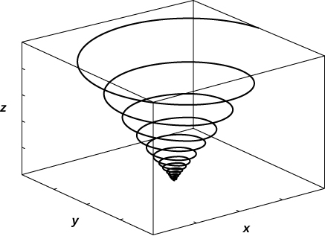

**Find a vector function that describes the following curves.**

211. Intersection of the cone  and plane 

Answer: 

**Find the derivatives of     and  Find the unit tangent vector.**

213. 

Answer:      unit tangent vector:

**Evaluate the following integrals.**

215.  with 

Answer: 

**Find the length for the following curves.**

217.  for 

Answer: 

**Reparameterize the following functions with respect to their arc length measured from in direction of increasing .**

219. 

Answer: 

**Find the curvature for the following vector functions.**

221. 

Answer: 

223. Find the tangential and normal acceleration components with the position vector

Answer:  

225. The position of a particle is given by  where  is measured in seconds and  is measured in meters. Find the velocity, acceleration, and speed functions. What are the position, velocity, speed, and acceleration of the particle at 1 sec?

Answer:  m/sec,   m/sec; at   m,  m/sec,  m/sec2, and  m/sec

**The following problems consider launching a cannonball out of a cannon. The cannonball is shot out of the cannon with an angle  and initial velocity  The only force acting on the cannonball is gravity, so we begin with a constant acceleration **

227. Find the position vector  and the parametric representation for the position.

Answer:  

**Student Project**

**Navigating a Banked Turn**

1. Find the velocity function  of the car. Show that **v** is tangent to the circular curve. This means that, without a force to keep the car on the curve, the car will shoot off of it.

Answer: The velocity is  To show that **v** is tangent to the curve, we confirm that 



3. Find the acceleration **a**. Show that this vector points toward the center of the circle and that 

Answer: 

A similar calculation as in 1. will show that  and therefore  is perpendicular to The negative signs cause the vector to point inward (toward the origin) rather than outward.



5. Show that  Conclude that 

Answer: The vertical component of the  force is  The vertical components of gravity and  are  and  respectively. These are all of the vertical forces, and they have to balance:



Adding  and  to both sides yields the desired equation. To prove the second equation, note that



because 

Therefore



which implies that



Hence we have



7. Show that  Conclude that the maximum speed does not actually depend on the mass of the car.

Answer: From the equation and from 6. we have that



Multiplying both sides by  and dividing both sides by  yields the desired equation. Since  does not appear on the right-hand side of the equation, the maximum speed does not depend on the car’s mass.

9. In dry conditions, how fast can the car travel through the top of the turn without skidding?

Answer: In this setup, Therefore



Hence the maximum speed is approximately  Converting to mph yields a maximum speed of 

11. Suppose the measured speed of a car going along the outside edge of the turn is 105 mph. Estimate the coefficient of friction for the car’s tires.

Answer: In this setup,  Furthermore, we assume that a professional driver is driving at a speed as close to the maximum speed as possible, so we estimate  to be  Converting to feet per second gives a maximum speed of  Therefore



and we solve this equation for  In this course of our calculations, we’ll keep four digits after the decimal place in order in order to minimize rounding error.



Notice that this makes physical sense: since we have decreased the maximum speed by a small amount ( has dropped to ), there is a corresponding small drop in the coefficient of friction ( down to ).

This file is copyright 2016, Rice University. All Rights Reserved.